

[PROJECT NAME]
Business Requirements Specifications

[First Draft]
NETIGY EA#: xxxx-xx

Submitted to (Client representative’s name, title, organization)

Submitted by

Date Submitted

Netigy Corporation

The information contained in this document is confidential to NETIGY and the above named client.
Table of Contents
Executive Summary 5
Purpose of the Project 5
Project Scope 5
Business Requirements 5
Inputs 5
Outputs 5
Functional Requirements 5
Physical Environment 5
Protocols 5
Addressing Schemes 5
Routed/Bridged 6
LAN Network Medium 6
WAN Network Medium 6
Security 6
Traffic Types 6
Account Information 7
Key Project Contacts 7
Site Access 7
Current Environment Review 8
Network Topology Review 8
Network Traffic Review 9
Network Management 9
Security 9
New Business Requirements 10
Product Perspective 10
Evolution 10
System Requirements 10
System Failure Business Impact 11
Financial Constraints 11
Risk Factors 11
Time Scales 11
End User Considerations 11
In-house Management Considerations 11
Training Issues 11
On-Going Support Issues 12
Change Control Program 12
Functional Perspective 12
User Characteristics 12
General Constraints 12
Other Requirements 12
Reusability 12
Deliverables 12
Documentation Requirements 12
Training Requirements 13
Quality Assurance Requirements 13
Security Requirements 13
Data Conversion Requirements 13
Open Issues 14
Approvals 15
Appendix A. Definitions, Acronyms, and Abbreviations 16
Appendix B. References 16

Document Control
Revision | Date | Revision Description
Version 1.0 |  | Initial setup of document

General GUIDELINES for completing the Business Requirements form:
- The Business Requirement form is a self-contained document used to gather the Client’s needs.
- Scale the sections of the Business Requirements form to the magnitude of your project. Some sections may require only a few lines for small projects; for large projects, some sections may be several pages long, a separate document, or an entire manual.
Please note: Text or items in italics or in brackets are instructions for creation of the Project Plan and may be removed and substituted with relevant information. Delete items that do not apply
__________________________________________________________________________________

Executive Summary
The Executive Summary is intended to provide the Project -at-a-Glance. It briefly summarizes selected sections in the Project Plan. It should highlight the salient points of the plan in a page or two.

Purpose of the Project
Identify the purpose of the project
Example: Business Problem/Opportunity and Desired Business end state

Project Scope
Explain (high level) what the project will and will not do. In order to specify a system satisfying all the criteria set by the organization the business requirements of the company must be recognized. These business requirements can be split down into a number of categories.

Business Requirements
Describe Purpose of the function from a business perspective (who uses, why, how and for what?) Include the approaches and techniques if known. Identify any calculations required to transfer the Inputs and Outputs.

Inputs
Identify all data input to this function from a user viewpoint. Include the source, quantity, timing and the range of valid inputs to address accuracy and tolerance issues.

Outputs
Identify all data outputs from this function from a user viewpoint. Include the destination, quantity, timing and the range of valid outputs to address accuracy and tolerance issues.

Functional Requirements
This is the most important and largest section of the BRS. The requirements should be specified as completely and thoroughly as is known at time, even this if evolutionary revisions can be foreseen. A formal change control process is required to identify, control, track, and report project changes. Before organizing the specific requirements, review the various items that comprise requirements and organize them to maximize readability.

Physical Environment
For all areas where equipment will be deployed, the physical environment should be defined. Are there space limitations within existing network racks? Is there sufficient air conditioning and power for all the proposed equipment? Does the client have any preference for access to site (see section 1.3)

Protocols
What protocols are will be added to the current network? E.g. IP, IPX. This would also include what frame types are to be used. E.g. Ethernet II, 802.2, etc.

Addressing Schemes
The planned addressing schemes and any special requirements for addressing should be highlighted here, like numbered links or class B subnetting in a bridged environment.

Routed/Bridged
In conjunction with the Addressing scheme the method of using that scheme should be described in this section. Preferred WAN architecture should be determined that would fit into the existing infrastructure. At this point the most efficient WAN segmentation method can be applied.

The client may want to route IP while bridging IPX over the WAN. Within the client constraints NETIGY must attempt to insure that the equipment proposed is appropriate for the size and complexity of the network.

LAN Network Medium
This section should determine the preferred Network medium on both ends of the WAN. The client may request a Thin Ethernet network remotely while requiring UTP at the central site.

WAN Network Medium
The preferred method for WAN connectivity should be detailed here. If the access to the central site is going to be greater than 3 hours every day, it might be appropriate to have a Leased Line solution rather than ISDN. Alternatively, the client may request that Frame Relay be utilized in all parts of the company including the proposed implementation.

Security
Are there any special requirements for the security of the system? This might include the use of a TACACS + server of the integration of the proposed Access Builder network into Windows NT authentication.

Traffic Types
What traffic types are going to be used in the new network? Are there any special filtering requirements what need to be addressed to stop protocol distribution?

Account Information

Key Project Contacts
List key project contacts and their information here. Information will be transferred to the Contact List.
Name | Title | Contact Numbers | Location/e-mail

Site Access
CLIENT’S PREFERENCE FOR SITE ACCESS
Any special security requirements  (Government clearance etc.) | To be discussed
Installation preferred during what hours | To be discussed
Access to Site for NETIGY personnel | To be discussed
Site Contact and telephone number(s) | To be discussed
Accompanied or Unaccompanied | To be discussed

Current Environment Review
This section is designed as a guide enabling NETIGY to fully understand client and potential client network designs and infrastructures. It has been structured in such a way as to categorize network components that can be easily analyzed, formulating an overall ‘picture’ of the network.

Network Topology Review
Figure 1 - Graphical Representation of Topology
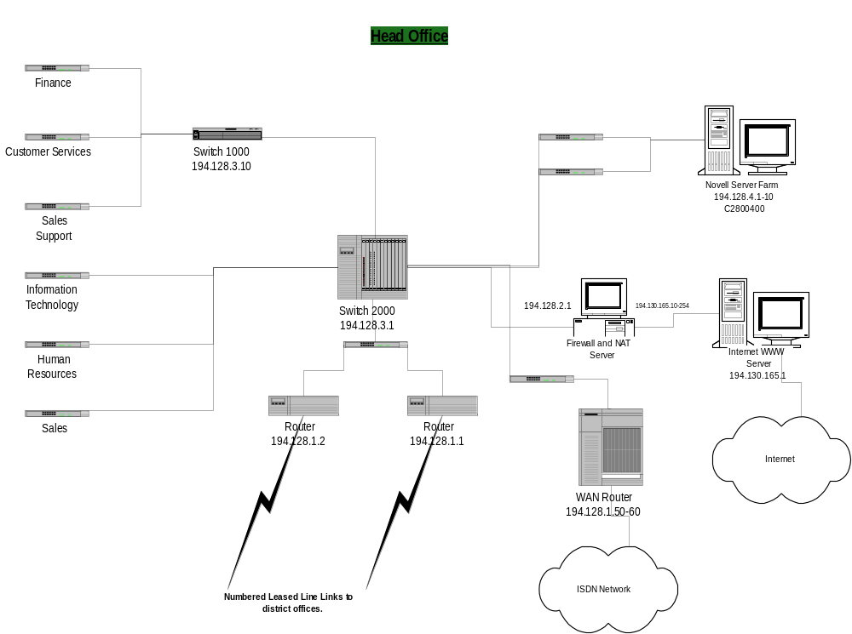

This section should give a graphical representation of the current network topology. The diagram should include the following information.

- All ‘types’ of network (e.g. Head Office, Regional Office, and Sub-Office).
- Examples of the network addressing schemes (e.g. IP addresses, IPX addresses, LSP area addresses).
- Examples of numbers of network devices (e.g. PC’s, printers, servers, routers, bridges).
- Type of LAN
- Technology utilized (e.g. Thin Ethernet, Unshielded Twisted Pair (UTP), and Token Ring).
- Type of WAN technology utilized (e.g. BT Kilostream, ISDN BRI, ISDN PRI (DASS2)).

For each graphical representation given a section should be written describing how the LAN/WAN is structured. This should be aimed at providing information that is difficult to portray graphically. It may annotate how the devices are setup, i.e. what protocols are loaded on the machines, what the operating system is, or how many hubs are attached.

Network Traffic Review
This section is designed to outline the traffic types and patterns in the network being analyzed. In order to obtain a compressive view of the traffic it may be necessary to ‘probe’ the network at different points and times.

Network Management
This section should highlight what management packages are currently being used on the system e.g. HP Openview, Transcend version 5.

Security
This section should highlight the levels of security that are evident in the network. This would also include additional software and hardware packages that have been installed to increase security. (TACACS+ servers, CLI, encrypted passwords)

New Business Requirements

Product Perspective
This subsection of the BRS puts the project into perspective with other related projects.

Evolution
How the system is projected to evolve over a given time period is important in order to ‘future proof’, the system as much as possible. Does the company plan to increase the traffic levels at all the sites with the inclusion of an Intranet, or a Groupware package? This information must be clearly defined and understood in both the client and NETIGY organization.

System Requirements
This category should highlight what exactly the system is being designed to achieve. By this what will be users on the network be trying to achieve, e.g.. the users log into a central UNIX server to run the parts ordering system. This logging on will only occur once a day at around 4:30pm before the outlet closes to replenish sold stock. Alternatively the system may be used for e-mail, file and print services and VT100 access to the UNIX server, leading to a much higher usage and frequency of call.

Service Level Requirements
Specify the requested Service Level Requirements relating to time, performance, and availability. Service level requirements are updated during the functional design and acceptance testing.

Performance Requirements
The performance of the system should be discussed here indicating what the expectations of the system are from the clients’ viewpoint. This would include connection time (if ISDN is involved), throughput ratios, compression rates, etc.

This may include screen response time, report response time, data timeliness etc. Identify the desired performance and if possible, associate additional cost necessary to achieve that performance. Specify the desired range of response time/data timeliness, particularly critical time issues to Netigyure project success and return on investment. Include any qualifications to clarify from what point to what point the measure and goal are to include and the load level (normal, peak, etc.). Specify the loads the system must handle. The loads are stated as numerical requirements placed on the product or on human interaction with the product as a whole. These may include the number of terminals supported, the number of simultaneous users to be supported, or amount and type of information to be handled.

Reliability and Availability Requirements
The reliability of the system must be defined here. Acceptable levels of equipment failure, and network circuit failure should be determined so that an availability matrix can be established, which would indicate times of critical importance for the equipment to be running. E.g.. Friday night file transfers to a remote server for price updating. Consequently the WAN must be available for this update every week. In turn this will give the network designers an idea of the resilience level requirements. (failover units, redundant power supplies, ISDN backup circuits, etc.).

Specify the prime times/days when the system is needed to be available for the business. This will be the period when failures will be counted against service levels. Specify the outage windows for regularly scheduled outages and/or optional outage windows for on request outages. Specify any other availability requirements. Rather than specifying the percent of the time the system is available; specify more specific measures that relates to quantifying business impact. The measurement units are usually hours or minutes and/or number of occurrences.

Specify for each service measurement point:
- The tolerable duration of each incident of end-user down time when the system is unavailable due to a failure
- The tolerable frequency of incidents for failure down time
- Any detail scope parameters to clarify what the measure are to include or exclude.
- The client’s business impact from a failure and their current performance objective.
- For each measure specified above, whether the measure is an outage (critical impact, highest priority, include only 2 to 4 measures) or impairment (important but not the highest priority). Examples of an outage are system-wide outage or departmental outage.

System Failure Business Impact
It should be determined what impact a system failure has on the workings of the business. This can dramatically alter the requisites of the proposed system depending on the cost per hour that the system is down. For instance if the proposed network is to nation-wide access for EPOS systems, and the EPOS cannot operate without the WAN being operational, then the emphasis on the network design is critical.

Financial Constraints
The financial constraints being placed on the project should be determined at this point. This will be subject to the allowable budget allocation for the roll-out. This information may be sNetigyitive.

Risk Factors
Are there any risk factors that should be considered during the proposal and subsequent rollout of the project that may effect the overall design of the system. Examples of this might include inherent partnerships with communications providers like Mercury (who are unable to provide Cli on ISDN). Once identified, these should be entered in the Risk Management Plan.

Time Scales
The project time scales should be documented. These time scales can then be translated into a project schedule where the project can be managed by the project team at NETIGY.

End User Considerations
This section concentrates on the emphasis of the end-user in the network. Questions such as the ones highlighted below should be asked to Netigyure that NETIGY are aware of who is responsible for the system and that the solution will fulfill their requirements. Will the end-user be required to have any knowledge of the system? Should there be any supporting documentation distributed to the end-user? What do the end-users expect from the system in terms of ease-of-use, performance, etc.?

In-house Management Considerations
This section can be split into two areas; Who will be managing the network infrastructure and how and where will that management occur? Is there going to be a dedicated team who will manage the proposed system from a single site or is the management going to be outsourced to a third party. What checks, if any, are required to test the network functionality (backup on demand, etc.)?

Training Issues
In order to plan the amount of training that needs to happen to make the network rollout succeed, the knowledge base of the users and network staff has to be determined. Has the company had previous experience with the equipment to be installed? Are Other Remote Access products being utilized within the network, are the partners involved (if any) trained to the required level on the proposed components?

On-Going Support Issues
This section should deal with the post implementation support plans. After the initial rollout of the equipment who will be used to support the WAN? Will they require support directly from NETIGY, in which case do they need/have an escalation path within the NETIGY management structure?

Change Control Program
Does the company have a change control program in place? Does this program meet the requirements laid out by NETIGY for the implementation processes that will need to occur?

Functional Perspective
The functional overview describes the client’s business problem addressed by the solution proposed by the project. State specifically the opportunity or business need for the project from a business perspective.

User Characteristics
Describe the general characteristics of the intended users of the product that will affect the specific requirements. Many people interact with a system during the operation and maintenance phase of the product. Consider the type of personnel, education level, experience, and technical expertise

General Constraints
Provide a general description of any other items that will limit the consultant’s options for designing the system. It should also include the reasons why certain specific requirements or design constraints are affected. Some of the constraints could include: (Identify the following)
- Product Life Span
- Volumes
- Regulatory requirements
- Hardware limitations
- Interfaces to other applications
- Parallel operations
- Audit functions
- Language requirements
- Client’s Network Requirements and Limitations
- Critical Dependencies

Other Requirements

Reusability
Identify if the system requirements or functions you have are discovered already exist in the Client’s network.

Deliverables
List of the specific deliverable of the project, i.e., capabilities, reports, deign, consultation, training, documentation, etc. that NETIGY agrees to deliver to the client.

Documentation Requirements
Identify any documentation requirements that exist

Training Requirements
Identify any training requirements that exist. Example: On-line, CBT, On-Site, Instructor Lead

Quality Assurance Requirements
Include the following information:
- Describe the general testing approach.
- Describe business acceptance criteria.

Security Requirements

Data Conversion Requirements

Open Issues
Open issues are all open issues at this point in the project life cycle.
# | Issue | Date / Actions Taken / Next Steps | Owner | Target Date | Status
001 |  | 01/01: |  |  | Open
 |  |  |  |  | Closed

Approvals

Name / Title | Approved | Signature/Date
NETIGY Lead Technical Consultant
NETIGY Project Manager (optional)
NETIGY Consulting Services Manager
Client’s Representative

Appendix A. Definitions, Acronyms, and Abbreviations
Provide the definitions of all terms, acronyms, and abbreviations required for proper interpreting the Business Requirement Specification (BRS).
Reference here if this section is moved to the appendix.

Appendix B. References
Provide a complete list of all documents referenced elsewhere in the BRS.
Identify each document by title, report number (if applicable), date, and publishing organization.
Example: NETIGY Engagement Agreement number, Meeting Minutes from Clients’ meeting, etc.
Specify the sources from which the reference can be obtained.
This subsection can appear in an appendix.

